**SIMULATION OF CARTESIAN 3D PRINTER MACHINE**

**EXPT No : 3 DATE:**

**AIM:**

To simulate the construction of cartesian 3D printer and to get in-depth knowledge of mechatronics of cartesian 3D printers.

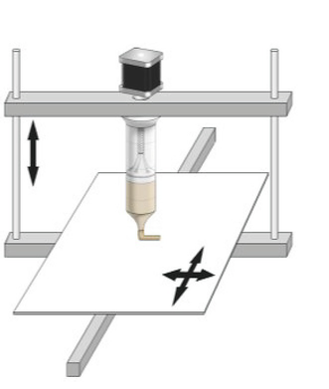

**REQUIREMENTS:**

* System - Windows 7 or higher, 1 GB RAM.

**PROCEDURE:**

**For X-Axis Assembly**

1. Select X-Axis Assembly from the visible list.
2. All the parts related to X-Axis will be shown on the screen.
3. Select the parts in sequence in which they are shown.
4. When the first part is selected then it will open in the blank space in the left side of the screen.
5. Further, when the correct part will be selected then it will get assembled with the previously selected part/parts.
6. If the user follows an incorrect sequence then a pop-up will appear on the screen showing the name of the part to be selected.

**For Y-Axis Assembly**

1. Select Y-Axis Assembly from the visible list.
2. All the parts related to Y-Axis will be shown on the screen.
3. Select the parts in sequence in which they are shown.
4. When the first part is selected then it will open in the blank space in the left side of the screen.
5. Further, when the correct part will be selected then it will get assembled with the previously selected part/parts.
6. If the user follows an incorrect sequence then a pop-up will appear on the screen showing the name of the part to be selected.

**For Z-Axis Assembly**

1. Select Z-Axis Assembly from the visible list.
2. All the parts related to Z-Axis will be shown on the screen.
3. Select the parts in sequence in which they are shown.
4. When the first part is selected then it will open in the blank space in the left side of the screen.
5. Further, when the correct part will be selected then it will get assembled with the previously selected part/parts.
6. If the user follows an incorrect sequence then a pop-up will appear on the screen showing the name of the part to be selected.

**For Complete-Axis Assembly**

1. Select Complete-Axis Assembly from the visible list.
2. All the parts related to Complete-Axis will be shown on the screen.
3. Select the parts in sequence in which they are shown.
4. When the first part is selected then it will open in the blank space in the left side of the screen.
5. Further, when the correct part will be selected then it will get assembled with the previously selected part/parts.
6. If the user follows an incorrect sequence then a pop-up will appear on the screen showing the name of the part to be selected.

**Playing with Axes**

1. Move the x-axis slider or enter the value (within the given range) in the given text box and press/select ENTER. Now observe the movement of the x-axis assembly.
2. Move the y-axis slider or enter the value (within the given range) in the given text box and press/select ENTER. Now observe the movement of the y-axis assembly.
3. Move the z-axis slider or enter the value (within the given range) in the given text box and press/select ENTER. Now observe the movement of the z-axis assembly.

**OUTPUT**

|  | Smooth Rod : smooth rods are typically used to support and guide the print head and print bed as they move |
| --- | --- |
| Bearing :The round, wheel-like devices are used to carry loads and reduce friction between two moving parts. |
| Idler :idler wheel is used to push the filament into the teeth of the drive wheel. |
| Extruder:extruder is responsible for pushing the filament along, melting it, and placing it on the bed to build the model |
| Motor:they help in moving a object to a repeatable position. |

**Fig 1: X Axis Assembly**

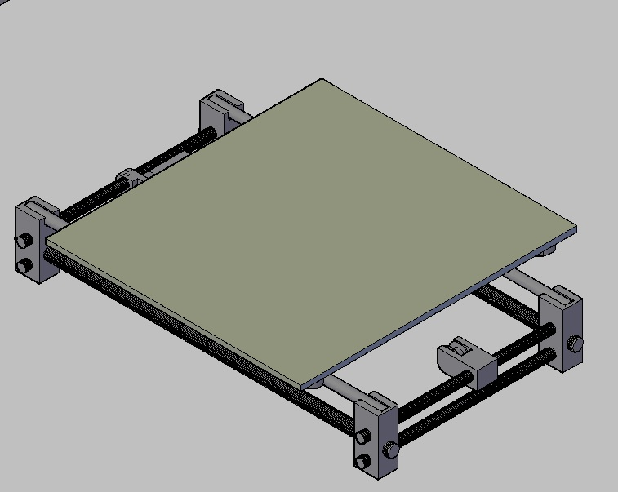

|  | Y-Axis Supporter :y-axis supporter is used to move the print head forward and backward |
| --- | --- |
| Horiz. & Vertical Threaded Rod :Horizontal and vertical rods shave off the base material in subtractive manufacturing methods until the desired shape is achieved. |
| Smooth Rod : smooth rods are typically used to support and guide the print head and print bed as they move |
| Pulley :they are the component that transmit the force of the motor to the filament. |
| Motor :they help in moving a object to a repeatable position. |
| Y-Axis Frame : Y axis on a printer represents movement forward and back. |
| Y-Axis Base :the Y axis base on a printer provides movement forward and backward. |

**Fig 2: Y Axis Assembly**

|  | Z-Axis Rod :The movement system used for the z-axis in 3D printing is typically based on a threaded rod or leadscrew that rotates to move the print bed or extruder up and down |
| --- | --- |
| Z-Axis Top Cover :z axis base provides basic vertical movement. |
| Motor :they help in moving a object to a repeatable position. |

**Fig 3: Z Axis Assembly**

|  | Frame :Cartesian-style printers consist of a rectangular frame wherein the nozzle can move along the X,Y and Z axes. |
| --- | --- |
| Y-Axis assembly :the Y axis on a printer represents movement forward and back. |
| Z-Axis Assembly : Z offset is a parameter that adjusts the initial height of the print nozzle above the bed. I |
| X-Axis Assembly :The X axis on a 3D printer is usually the lateral movement left to right (or vice versa) |
| SMPS :Shape memory polymers (SMPs) are polymers which ''remember'' their original shape and can return to it after deformation, if an external stimulus—often an increased temperature – is applied. |
| LCD :LCD (Liquid Crystal Display) printers are resin-based (or vat-polymerization) 3D printing technologies. Both processes work thanks to a photosensitive resin that is stored in a tank and cured by a light source. This light source is used to solidify the resin. |
| Spool Holder :The spool fits on a roller called spool holder normally on the back of the 3D printer. |
| Spool :The ABS /PLA is heated as it is drawn through the print head, which moves side to side. As the print head moves, it lays down a layer. This is slowly built up, producing the final 3D object. |

**Fig 4: Completed Assembly**

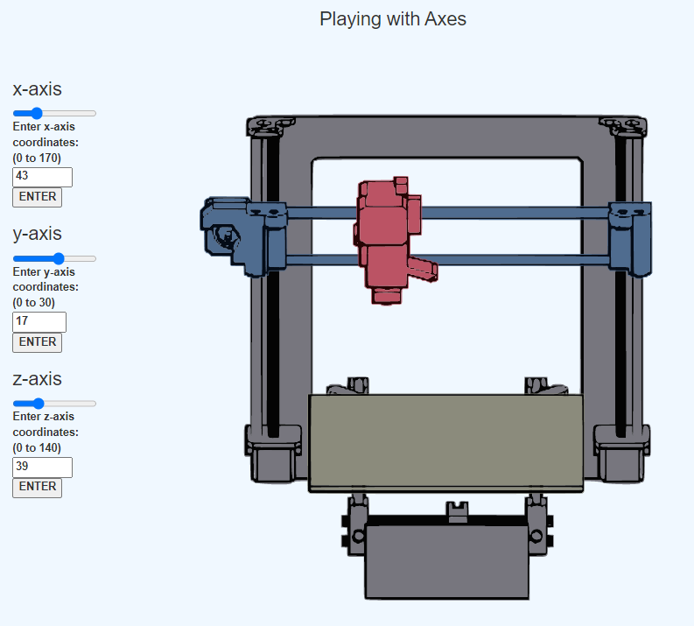

**Fig 5: Playing with Axes**

**Result:** Thus the simulation on construction of cartesian 3D printer is completed & movement of axis along X, Y, & Z has been studied.